Jenkins SSH publish

Which means send file from local or remote node machine to other Machine over SSH and execute the copied file

To do this need to install SSH publish agent

Then create a public key and private key as discussed in Jenkins installation document

Put the pub_key in the Know_hosts or authorized_key file in the client side.

Then go to

Manage Jenkins->Configure systems-> under “Publish over SSH”

In Key column, paste the private key

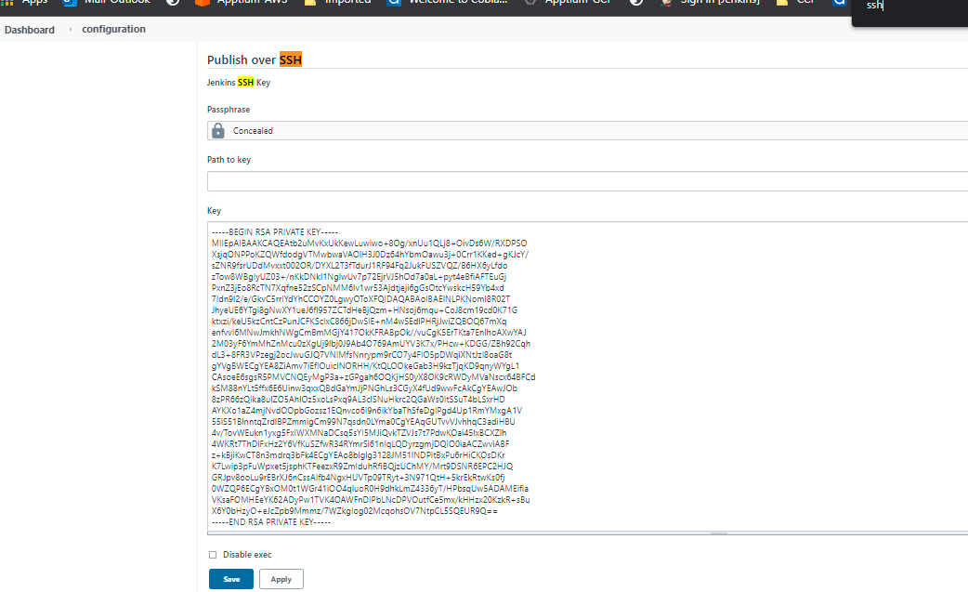

Then in “Add Server” section add all the client information to which you have copied the pub_key in to it.

**Name:** To be called in the Jenkins job config page

**Hostname:** Ip of the client server to which you want to connect

**Username:** at what username you need to login -> mostly ec2-user

**Remote Directory:** To which directory you need to login to /home/ec2-user/

